# Lab 21: Route Parameters

## Objectives

*  Navigate to a route with a parameter

## Steps

### Navigate to a route with a parameter

1. **Add** a find **method** to projectAPI to return a single Project by id

#### src\projects\projectAPI.js

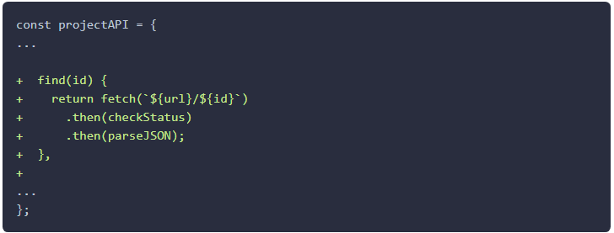

1. **Copy** the files snip-master\labs\js\snippets\lab21\ProjectPage.js and ProjectDetail.js] into the src\projects directory.

These files contain some pre-built components we will use in this lab. Take a moment to review the code in them.

1. Add a route to display the ProjectPage (notice that we now have a ProjectPage and a ProjectsPage so be careful you are in the correct file).

#### src\App.js

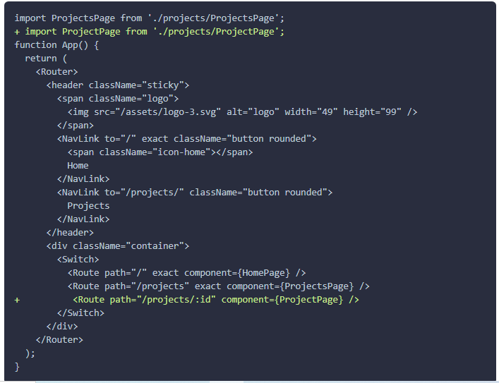

1. Make the name and description clickable by adding a <Link /> component around them.

#### src\projects\ProjectCard.js

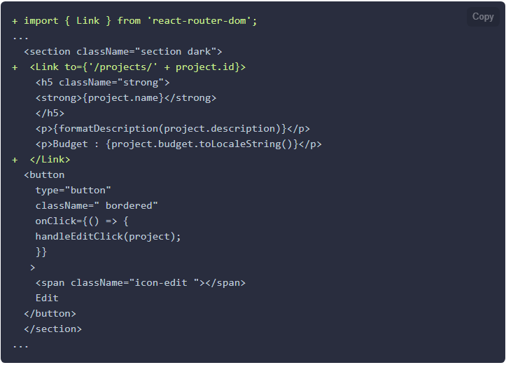

1. **Verify** the new **route** works by the **following these steps**:
   1. **Visit** the root of the site: http://localhost:3000/ and refresh the page in your browser.
   2. **Click** on Projects in the **navigation**.
   3. **Verify** you are taken to the /projects route and the ProjectsPage **displays**.
   4. **Click** on the name or description in any of the project cards .
   5. **Verify** you are taken to the /projects/1 route and the ProjectPage **displays** the ProjectDetail component.

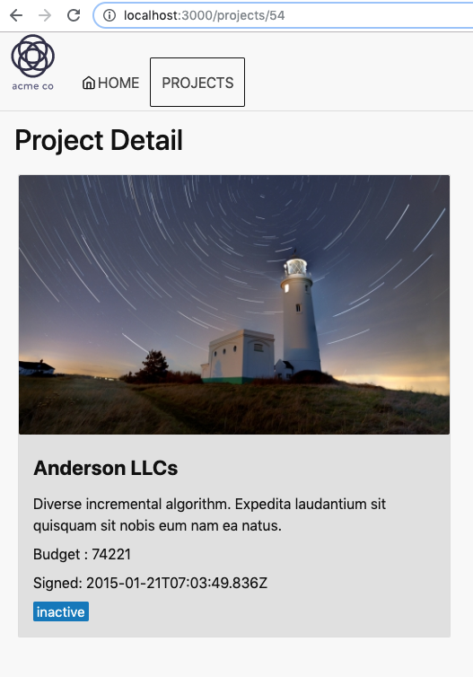

### ✔ You have completed Lab 21